Next Gen Employability Program



**NEXT GEN EMPLOYABILITY PROGRAM**

Creating a future

-

ready workforce

Team Members

Student Name :

Parthasarathy p

Register ID :

110321104

035

College Name

Grt Instuite Of Engineering

And Technology



Next Gen Employability Program



**CAPSTONE PROJECT SHOWCASE**

**MUSIC WEB APPLICATION USING DJANGO FRAMEWORK**

**Project Title**

Abstract | Problem Statement | Project Overview |

Proposed

Solution

|

Technology Used

| Modelling & Results

| Conclusion

# Abstract

The main goal of this project is to create an extensive music web application that seamlessly combines frontend and backend technologies. This involves blending HTML, CSS, and JavaScript to craft a userfriendly and visually appealing frontend interface. On the other hand, the backend structure will be strengthened using Python, utilizing the powerful capabilities of the Django framework to ensure efficient data handling, smooth communication with the SQL database, and the implementation of advanced serverside features.

By harmonizing these technological elements, the overarching objective is to provide users with an exceptional experience, enabling easy access and meticulous management of music content. The application's primary functions will include intuitive browsing, dynamic search functions, immersive playback experiences, and seamless organization of music tracks. Additionally, it will integrate advanced features like user authentication for enhanced account security, intuitive playlist creation for

personalized content arrangement, and intelligent recommendation algorithms to elevate user interaction and satisfaction.

Source :

# Problem Statement

With the proliferation of digital music platforms, there's a growing demand for feature-rich music applications that cater to diverse user preferences. Existing platforms may lack certain functionalities or fail to provide a cohesive user experience. Additionally, users often encounter issues related to content organization, personalized recommendations, and seamless navigation. Thus, there's a need for a robust music web application that addresses these shortcomings and offers a compelling solution to users seeking an immersive music streaming experience.

Existing platforms fail to provide a cohesive user experience and often lack key features, such as personalized recommendations and seamless navigation. Users encounter issues related to content organization and efficient access to desired music tracks. Consequently, there is a clear need for a comprehensive music web application that addresses these shortcomings and offers users a seamless and engaging music streaming experience.

# Project Overview

The objective of the music web application project is to create an inclusive and easy-to-use music streaming platform by integrating frontend and backend technologies seamlessly. By utilizing HTML, CSS, and JavaScript for the frontend, the application will offer an interface that is intuitive and visually engaging. Meanwhile, the backend, supported by Python with the Django framework, will facilitate efficient data handling, authentication processes, and database interaction.

The application's design will cater to a range of functionalities, encompassing user registration and login procedures, as well as features such as browsing, searching, and playback of music tracks. Additionally, users will be able to manage playlists and receive personalized recommendations. Through this comprehensive approach, the project aims to provide users with a cohesive and satisfying music streaming experience that aligns with contemporary standards of usability and functionality.

# Proposed Solution

In response to the identified challenges, the proposed solution entails the creation of a cohesive music web application that seamlessly merges frontend and backend technologies. The frontend will be meticulously crafted using HTML to structure the content, CSS to enhance its visual appeal, and JavaScript to infuse dynamic behavior, thereby ensuring an interactive and responsive user interface. Concurrently, the backend infrastructure will leverage Python in conjunction with the Django framework to manage critical aspects such as user authentication, data modeling, and interaction with the SQL database.

Through this integration, the application will adeptly handle user registration, login procedures, and offer a suite of features including music track browsing, search functionality, and playback capabilities.

Furthermore, users will have the ability to curate playlists and receive tailored recommendations, fostering a personalized and enriching music streaming experience. By embedding robust functionalities such as user authentication, content management, and sophisticated recommendation algorithms, the application endeavors to offer users an immersive platform that caters to their individual preferences and enhances their overall engagement with music content.

**Frontend Development:** The frontend of the application will be developed using HTML, CSS, and JavaScript to create an intuitive and visually appealing user interface. HTML will be used to structure the content of the web pages, defining elements such as headings, paragraphs, and lists. CSS will be employed for styling, allowing for customization of fonts, colors, layouts, and other visual aspects to enhance the aesthetic appeal of the application. JavaScript will provide dynamic behavior, enabling interactive features such as dropdown menus, modal pop-ups, and asynchronous data loading without page refreshes. By combining these frontend technologies, the application will offer a seamless and responsive user experience across different devices and screen sizes.

**Backend Development:** The backend of the application will be powered by Python with the Django framework, providing a robust foundation for data management, server-side logic, and interaction with the SQL database. Django's built-in features such as authentication, URL routing, and template rendering will streamline the development process and ensure the security and scalability of the application. The Django ORM (Object-Relational Mapping) will be utilized to define data models and perform database operations, abstracting away the complexities of SQL queries and database management. Additionally, Django's admin interface will provide an easyto-use tool for managing application data and user accounts, allowing administrators to add, edit, and delete content with minimal effort.

# Technology Used

Front-end Back-end

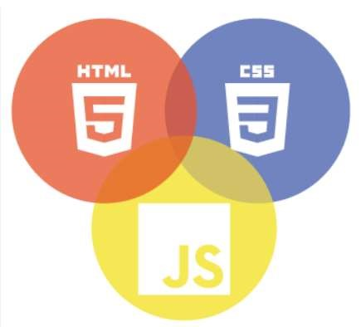

# Modelling & Results

The project will follow a model-view-template (MVT) architecture, a variation of the

traditional model-view-controller (MVC) pattern, where the model represents the data structure, the view handles the presentation logic, and the template manages the user interface. Django's built-in ORM (Object-Relational Mapping) will be used to define data models and interact with the SQL database.

Throughout the development process, iterative testing and debugging will be conducted to ensure the application meets functional requirements and performance expectations. User feedback and testing results will inform refinements and optimizations to enhance the overall user experience. Upon completion, the expected result is a fully functional music web application that offers a seamless and feature-rich platform for discovering, listening to, and managing music content.

# Homepage

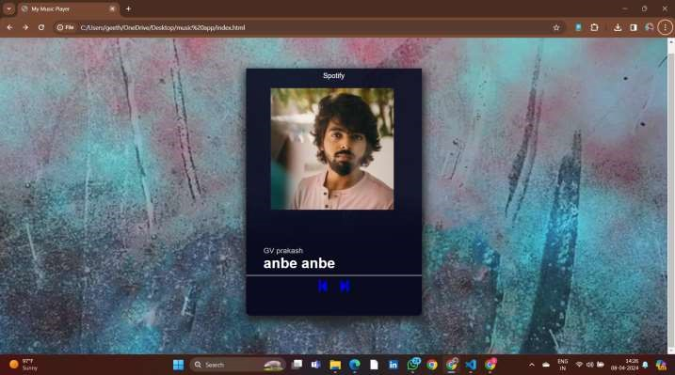

**Future Enhancements:**

Furthermore, enhancing the recommendation engine by leveraging machine learning algorithms

could significantly improve personalized recommendations based on user preferences, listening habits, and contextual factors. By analyzing user interactions and feedback data, the recommendation system could continuously adapt and evolve, providing increasingly accurate and relevant music suggestions over time.

Another area for potential enhancement is the integration of advanced audio processing

technologies, such as automatic music tagging, mood detection, and audio fingerprinting. These features could enhance music search and discovery capabilities, allowing users to explore music based on specific attributes like genre, mood, or tempo.

## Conclusion

The project's culmination marks the successful creation of a comprehensive music

web application, seamlessly intertwining frontend and backend technologies. This achievement is realized through the fusion of HTML, CSS, and JavaScript to sculpt an intuitive and visually captivating frontend interface. Meanwhile, the backend architecture is fortified using Python, harnessing the robust capabilities of the Django framework to ensure efficient data management, seamless interaction with the SQL database, and the implementation of sophisticated server-side functionalities.

Source :

**Thank You!**